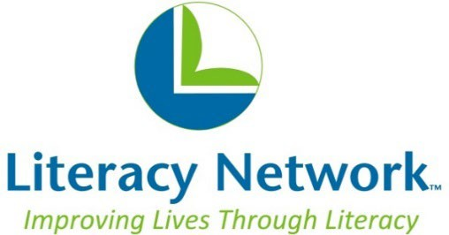
701 Dane Street
Madison, WI 53713
608-244-3911

Mission: Literacy Network helps adults in Dane County build skills, reach goals, and connect communities.

Board Application
Name
Phone number
Email address
Employer
Title
Address

Have you volunteered at Literacy Network in the past? If so, please explain the amount of time and in what capacity you have served.

Have you served on a non-profit board in the past? If so, please list.

Please list any additional background in volunteer of non-profit service, including years of service.

Please include any other civic or professional activities and affiliations:

What strengths would you contribute to Literacy Network?

Why are you interested in volunteering at Literacy Network?

