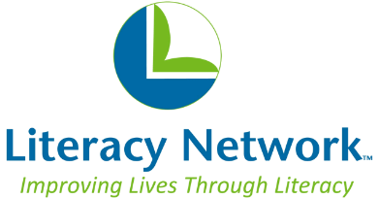
Mission: Literacy Network teaches reading, writing, communication, and computer skills to Dane County adults so they can achieve financial security, well-being, and deeper engagement with their families and the community.

Workplace Literacy: Sample Curriculum Topics

These are examples of topics which may be covered in a workplace literacy class. We know that each workplace is unique – Literacy Network will work with you to determine the specific needs of your employees and company!

- Workplace Communication
  - Asking questions
  - Understanding and responding to instructions
  - Asking for and giving clarification
  - Reporting progress or problems
  - Understanding schedules
  - Calling in sick or late

- On-the-Job Safety
  - Giving or responding to warnings
  - Following safety rules
  - Reporting problems
  - Following emergency procedures

- Job-Specific Language
  - Identifying and describing duties
  - Describing tools, equipment, or machinery
  - Discussing products and processes
  - Understanding quality control

- Cross-Cultural Understanding
  - Getting familiar with cultural values of the American workplace
  - Communicating professionally and making small talk
  - Practicing appropriate problem-solving strategies
  - Understanding “unwritten rules”

- Company Policies
  - Requesting time off
  - Interpreting benefits options
  - Understanding policies and procedures
  - Understanding evaluation processes

